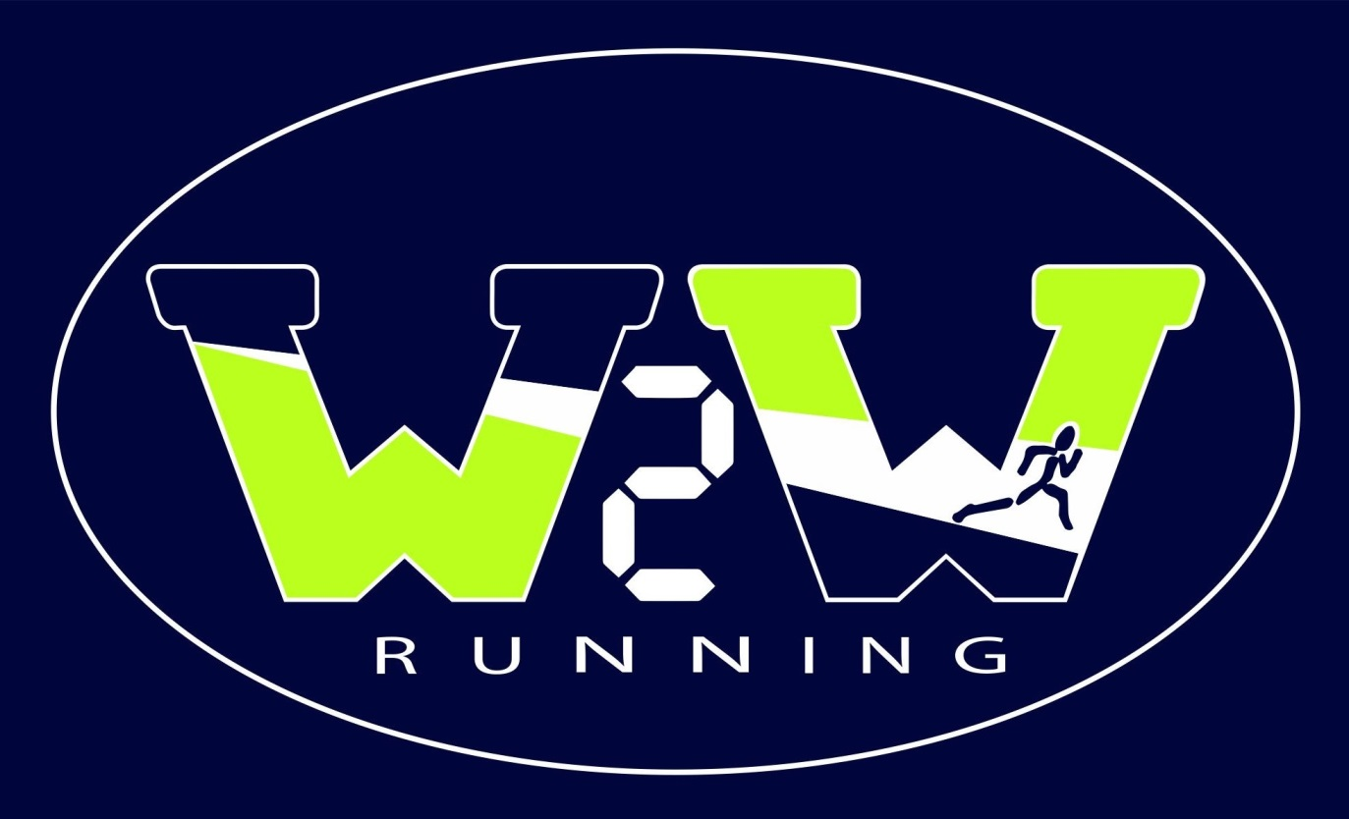
“W2W Elite TWENTY”
Each fall, as a part of its outreach mission, Wire2Wire Running recognizes several,
elite high school runners from Cartersville/Bartow Co. We select the TOP 10 Boys
& Top 10 Girls.

The parameters for selection are simple.
- A runner must run in at least half of his or her team’s scheduled meets.
- A runner must be in good academic standing.
- We will use a runner’s fastest time from the year, including Region & State.
- We invite the TOP 10 Boys & Top 10 Girls to our annual banquet.

NOTE: In the case of runners #10 and #11 having the same time, we will select the runner who won the head-to-head battle in the County Championship as our #10 runner. If each runner competed in a different race, then we will select the victor from the last time they faced each other head-to-head. If they never ran head-to-head, we will select them both.

